Name: _________________________________________________ Date: _______________________ Period: ______________
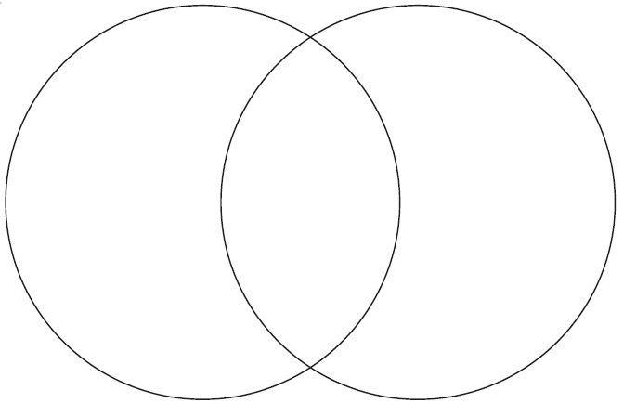
*Compare and contrast the characters of Ralph and Jack

